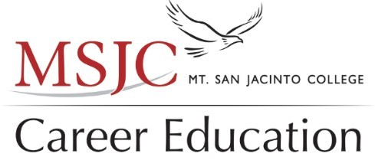Career Education Advisory Meeting

Friday, February 26, 2021
9:00AM – 11:00AM
Zoom Confer

- Welcome and Introductions – Dr. Marilyn Harvey and Von Lawson
- Background and purpose – Executive Dean Joyce Johnson
- SWP Program Updates – Avante Simmons
- Program Updates – Carrie Tate-Myer
- Internship and Apprenticeships – Arnita Porter and Tom Oxford
- Overview of MSJC Career Education Programs – Dr. Marilyn Harvey and Von Lawson

Breakout Session Participants:
Karen Cranney, Wine Liaison for MSJC and co-department chair
James Meier—Retail/Hospitality
Rick Linsalato – Culinary Arts Retail/Hospitality
Timothy Diaz – Retail/Hospitality
Stefano Butto – Sommelier - Retail/Hospitality and co-department chair

Retail/Hospitality was the breakout session where Karen Cranney presented the Wine Industry and Hospitality Program.
The certificate and degree proposal were presented at this meeting as it has been during the previous career advisory meetings.
As a result of the employment concentrations that currently exist, MSJC Viticulture and Enology program has changed its name and updated its proposed degree/certificate because the demand has been growing for trained personnel for our region. The Temecula Winegrowers Association and the southern California Regional Symposium on agricultural labor has attested to the need of trained agricultural workers but also for tasting room managers, hospitality and food pairing experts, and winery compliance.
Combined with our plans for culinary arts at Mt. San Jacinto College, we expect to be the leading local educational training center for viticulture, enology, and tasting room/winery management. We are coordinating with several local high schools who are very enthusiastic about our plans and eager to articulate their comparable plans for sustainable agriculture.
With the opening of the Temecula campus, we expect full scale operations to be developed that will include research partners with UCR and the city of Temecula which currently trains autistic young adults on the art of viticulture. We have plans to work with Spero Vineyard as a training vineyard. That property is currently used for training and we look forward to a long relationship with the family and the property to promote organic fertilizer and erase Pierce’s disease. UCR is extremely pleased and participating in this research project.

